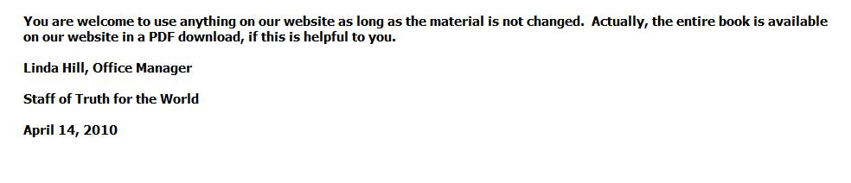

Brother West,

I like your format. There are no objections whatsoever to a format change. We even give permission to our teachers to remove our name from our printed materials and put their name and address on instead. The changes I meant were changes in the wording, to make the answers or tracts say something different than what was written originally and can be proven from the Bible.

We need more on the web teaching Christ and His church. Keep it up.

Linda

Staff of Truth for the World

P.S. Please include a copy of this email when you respond.

For a free Bible correspondence course go to www.tftw.org and follow the instructions in the large yellow box on the ONLINE COURSES page.

From: Gaylon West [mailto:gwest004@tampabay.rr.com]
Sent: Thursday, April 15, 2010 1:15 PM
To: Office Staff
Subject: Re: "Bible Answers to Commonly Asked Questions"

Dear Sister Hill,

I have uploaded the first section "God-Christ" questions that I had prepared from the booklet and you will be able to preview it at

http://biblestudylessons.net/faqs/God-Christ.html.

Your permission was limited by "as long as the material is not changed". Please notice that I have changed the format to match my "Frequently Asked Questions" section. You were generous in giving me permission to use the material so if what I have done is against the policy of TFTW I will erase it.

There's a lot of work to do it this way (for me) so I will not re-create the wheel for the rest of the booklet but link to your questions and answers site.

I'm glad for the good work your group is doing and thankful to the Lord for it. I should have checked to see if you had a website before I initiated this work.

God bless, Gaylon

----- Original Message -----
From: Office Staff
To: 'Gaylon West'
Sent: Wednesday, April 14, 2010 1:41 PM
Subject: RE: "Bible Answers to Commonly Asked Questions"

You are welcome to use anything on our website as long as the material is not changed. Actually, the entire book is available on our website in a PDF download, if this is helpful to you.

Linda Hill, Office Manager
Staff of Truth for the World

P.S. Please include a copy of this email when you respond.

For a free Bible correspondence course go to www.tftw.org and follow the instructions in the large yellow box on the ONLINE COURSES page.

From: Gaylon West [mailto:gwest004@tampabay.rr.com]
Sent: Sunday, April 11, 2010 11:04 PM
To: Office Staff
Subject: "Bible Answers to Commonly Asked Questions"

I have just received a copy of the "Bible Answers to Commonly Asked Questions" and request that I may copy some of the questions and answers on my website"biblestudylessons.net".

I'm formerly an elder of the Orange Street church of Christ in Auburndale, Florida.

Thank you for your response to this request.

In Jesus, Gaylon West

